# **HOW TO USE ACTIVE AND PASSIVE BUZZERS ON THE ARDUINO**

In this article, we will see how to use two different types of piezoelectric buzzers on the Arduino. Piezoelectric buzzers produce a loud noise. When connected to the [Arduino](https://www.amazon.com/gp/product/B008GRTSV6/ref=as_li_qf_asin_il_tl?ie=UTF8&tag=circbasi-20&creative=9325&linkCode=as2&creativeASIN=B008GRTSV6&linkId=e387d2ea29aa6ca1b2d2f67a8a00c430) they can be used as an alarm or notification when a motion sensor is triggered, or when a sensor reaches a certain value. They can also be programed to produce musical notes.

There are two types of piezoelectric buzzers that are commonly used in electronics projects – [active buzzers](https://www.amazon.com/Cylewet-Electronic-Magnetic-Continuous-Arduino/dp/B01N7NHSY6?keywords=active+buzzer&qid=1636601263&sr=8-5&linkCode=ll1&tag=circbasi-20&linkId=d8b0bd0871ed30529d2019950b686ba3&language=en_US&ref_=as_li_ss_tl) and [passive buzzers](https://www.amazon.com/Cylewet-Terminals-Electronic-Electromagnetic-Impedance/dp/B01NCOXB2Q?keywords=passive+buzzer&qid=1636780863&sr=8-7&linkCode=ll1&tag=circbasi-20&linkId=316984d8a41fa1bed5fa70da5a70eee3&language=en_US&ref_=as_li_ss_tl). Active buzzers are called active because they only need a DC voltage to produce sound. Passive buzzers need an AC voltage to produce sound.

Active buzzers and passive buzzers look very similar:

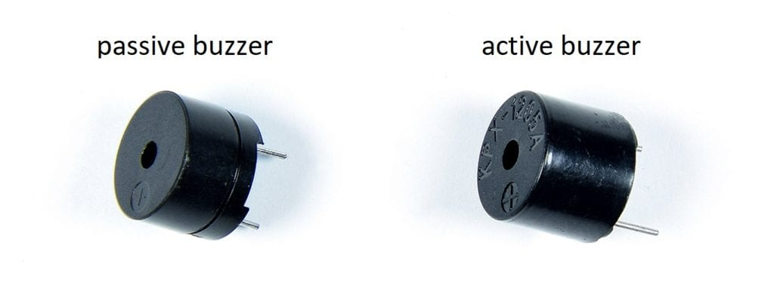

An easy way to tell active and passive buzzers apart is by connecting them to a DC voltage source like a 9 volt battery. The buzzers are polarized, so check which terminal is positive and which terminal is negative before connecting it to a battery.

When you connect a passive buzzer to a battery, the buzzer will make a sharp clicking sound. But when you connect an active buzzer to a battery, the buzzer will make a loud buzzing noise.

## **HOW TO CONNECT AN ACTIVE BUZZER TO THE ARDUINO**

Let’s build an example project that will control an active buzzer with the press of a button.

Here are the parts you will need:

* [Arduino Uno](https://www.amazon.com/gp/product/B008GRTSV6/ref=as_li_qf_asin_il_tl?ie=UTF8&tag=circbasi-20&creative=9325&linkCode=as2&creativeASIN=B008GRTSV6&linkId=e387d2ea29aa6ca1b2d2f67a8a00c430)
* [Jumper wires](https://www.amazon.com/gp/product/B07GD2PGY4/ref=as_li_qf_asin_il_tl?ie=UTF8&tag=circbasi-20&creative=9325&linkCode=as2&creativeASIN=B07GD2PGY4&linkId=830b215653e24d7801a496770987b18d)
* [Breadboard](https://www.amazon.com/gp/product/B07DL13RZH/ref=as_li_qf_asin_il_tl?ie=UTF8&tag=circbasi-20&creative=9325&linkCode=as2&creativeASIN=B07DL13RZH&linkId=ffac51d787abb539fe6e475bb1a7395a)
* [Tactile push button](https://www.amazon.com/gp/product/B0722LBKV7/ref=as_li_qf_asin_il_tl?ie=UTF8&tag=circbasi-20&creative=9325&linkCode=as2&creativeASIN=B0722LBKV7&linkId=58cb03f997247eeb417a4252a325721d)
* [Active buzzer](https://www.amazon.com/Cylewet-Electronic-Magnetic-Continuous-Arduino/dp/B01N7NHSY6?keywords=active+buzzer&qid=1636601263&sr=8-5&linkCode=ll1&tag=circbasi-20&linkId=d8b0bd0871ed30529d2019950b686ba3&language=en_US&ref_=as_li_ss_tl)

To connect the active buzzer and push button to the Arduino, follow the diagram below:

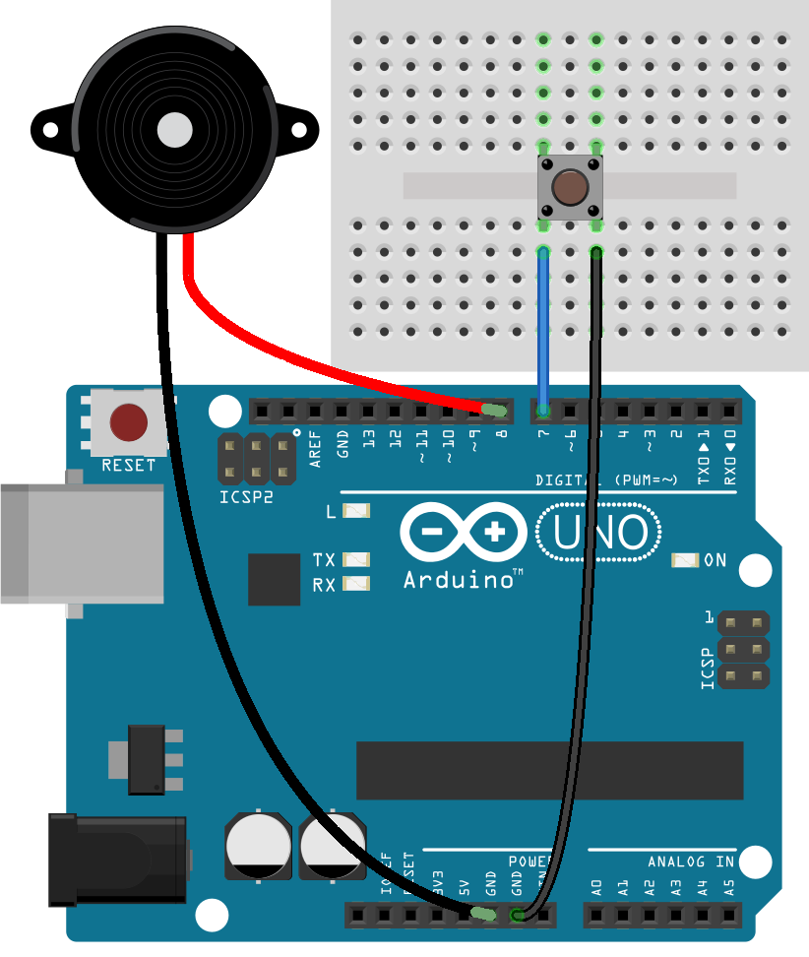

## **HOW TO PROGRAM AN ACTIVE BUZZER ON THE ARDUINO**

Once your circuit is connected, upload this code to the Arduino:

int buzzerPin = 8;

int buttonPin = 7;

void setup() {

pinMode(buzzerPin, OUTPUT);

pinMode(buttonPin, INPUT_PULLUP);

}

void loop() {

int buttonState = digitalRead(buttonPin);

if (buttonState == LOW) {

digitalWrite(buzzerPin, HIGH);

}

if (buttonState == HIGH) {

digitalWrite(buzzerPin, LOW);

}

}

## **HOW TO CONNECT A PASSIVE BUZZER TO THE ARDUINO**

Let’s build a circuit that cycles through a set of musical notes from A to G.

You will need these parts:

* [Arduino Uno](https://www.amazon.com/gp/product/B008GRTSV6/ref=as_li_qf_asin_il_tl?ie=UTF8&tag=circbasi-20&creative=9325&linkCode=as2&creativeASIN=B008GRTSV6&linkId=e387d2ea29aa6ca1b2d2f67a8a00c430)
* [Passive buzzer](https://www.amazon.com/Cylewet-Terminals-Electronic-Electromagnetic-Impedance/dp/B01NCOXB2Q?keywords=passive+buzzer&qid=1636780863&sr=8-7&linkCode=ll1&tag=circbasi-20&linkId=316984d8a41fa1bed5fa70da5a70eee3&language=en_US&ref_=as_li_ss_tl)

First, connect a passive buzzer to the Arduino like this:

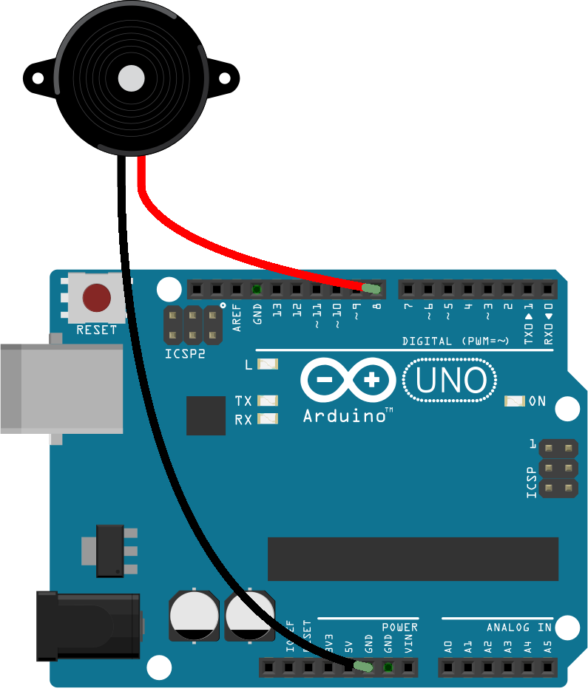

## **HOW TO PROGRAM A PASSIVE BUZZER ON AN ARDUINO**

Once the passive buzzer is connected, upload this code the Arduino:

int buzzerPin = 8;

void setup() {

pinMode(buzzerPin, OUTPUT);

tone(buzzerPin, 1000, 2000);

}

void loop() {

tone(buzzerPin, 440); // A4

delay(1000);

tone(buzzerPin, 494); // B4

delay(1000);

tone(buzzerPin, 523); // C4

delay(1000);

tone(buzzerPin, 587); // D4

delay(1000);

tone(buzzerPin, 659); // E4

delay(1000);

tone(buzzerPin, 698); // F4

delay(1000);

tone(buzzerPin, 784); // G4

delay(1000);

noTone(buzzerPin);

delay(1000);

}